**Homework:**

**3) Understanding DFT of images (2 points)**  
a) Explain shortly what information you can obtain from a DFT of an image.

Answer:

The density of gray level in frequency domain, but direction is perpendicular to the original one and

DFT is transformation from place domain ( I mean 2D,because it is image f(x,y)) to frequency domain. It means that every point is transfer to its sine and cosine components in average value.

We can conclude that every line will be perpendicular in frequency domain. Image (a)

And if our image is uniformed color in every place the DFT is circular image (b)

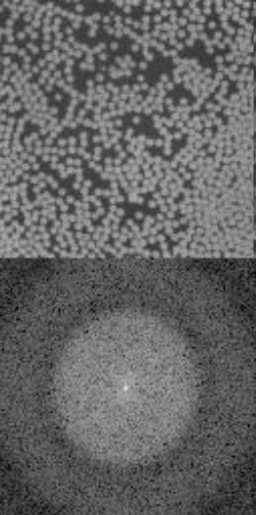

(a) (b)

b) Consider the images from task one. Where is the FFT energy concentrated in each case and why?

Include the images in your report and remember to label them. The images should be sufficiently large to see the  
details. Keep your answers concise and to the point.